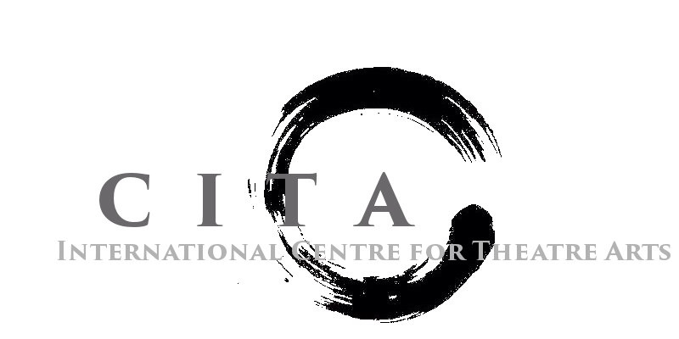

Scholarship Application Form

Each year CITA will offer an art scholarship to one student. This award is determined on a competitive basis and requires the submission of an artistic statement and resume. We strongly encourage you to participate in this process.
ARTIST STATEMENT
The Artist Statement should include your reasons for wanting to be an artist, a description of artists and/or work that you admire, and your artistic goals. There is no minimum or maximum word limit to your statement. Be sure to include your name at the top of your statement.
DEADLINE
Return this completed form along with your artist statement and resume to [citainternational@gmail.com], to be considered for the upcoming school year.

Please type:
Personal Information
Last Name: _________________________________
First Name: _________________________________
Address: ______________________________________________________________________________
City: _________________________ Telephone Number: (____) ________________
Email Address: _______________________________________________ _____
CHECKLIST for art scholarship:
______ 1) This completed application form
______ 2) One-page artist statement
CITA is not responsible for lost, stolen or damaged items.

